Phoenix-like Jonathan Mandell Breathes New Life into Broken Bits
By Mike Venema
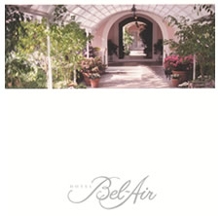Mosaic artist Jon Mandell is renowned for his meticulous craftsmanship that truly melds high craft with fine art. A lifelong resident of Philadelphia, Pennsylvania, Mandell has been creating mosaic art for over fifteen years. Mosaic is an ancient art form that predates canvas painting and classical sculpture. The process has changed little in the past 4,000 years. After sketching and painting his desired image on board, the artist assembles various stones, pottery fragments, and glass, among other materials. After matching the desired colors, the artist then shapes each piece on a grinding wheel. When the mosaic fits together in the artist’s desired form, it is secured in place by adhesive cement and then grouted.
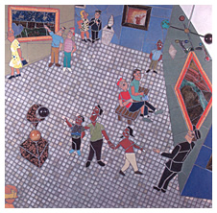

While still an undergraduate at Northwestern University, Mandell became fascinated with ancient mosaic art from the Mediterranean and Middle East. In 1988 he took a sabbatical from the University and traveled to Israel, Egypt, and Italy to study the work close at hand. Upon his return, he committed himself to the art form and began his career in earnest. There were immediate obstacles to overcome. Mosaic art in the United States was not even in its infancy . . . it was virtually undiscovered. The mosaics that most people recognized and understood were factory-produced tabletops, coffee tables, and related furniture. While decorative and often lovely, they were not true mosaic. Interestingly, the true mosaic work that Mandell produced looked almost foreign to the galleries and collectors who were exposed to the art. After several rejections, the artist reconsidered his approach and began to share his work and ideas with architects and interior designers who specialized in the liturgical world. Temples and churches were the most logical outlet for the large scale, monumental works that Mandell wanted to create. In 1990 he made his first important breakthrough with the creation of an Ark of Covenants at Gratz College in Philadelphia. Within months, his career was thriving with important architectural commissions from New York, Pennsylvania, and Las Vegas.
With the studio now successful, Mandell began to focus more attention on his non-liturgical work that explores figurative and abstract concepts. In recent years, he has created monumental works depicting baseball stadiums, boxers, and other sports-related scenes. Recently he contacted the family of the late basketball star Wilt Chamberlain with the idea of creating a life-size mosaic of the superstar. Mandell’s goal was to install the mosaic mural at Chamberlain’s Philadelphia alma mater, Overbrook High School. Both the Chamberlain family and the Philadelphia school board gave him their blessings and the work is now underway.
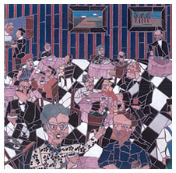
“By no means am I ‘married’ to any particular theme,” says Mandell. “David Hockney was synonymous with swimming pools for many years, Larry Rivers with historical themes. At this particular time in my career I take great pleasure in my sports-related images because they lend themselves to motion in a way that’s very fluid. There’s a restriction that the mind imposes on mosaic. Our first thought is that the image should be staid or static and I like to take an opposing view. I’m inspired by the paintings of Thomas Hart Benton that depict motion in an almost mechanical way and yet have the power to move through his genius of color and shading. Degas, too, is a powerful influence on my work. Movement is often my ultimate expression.”
Currently, Mandell is working on an abstract mosaic that almost defines his dedication to motion. Dubbed “Nisqually/Spring 2001,” the mosaic consists of shards of glass that were the result of the Tacoma-Seattle quake. Dale Chihuly, the world’s most renowned glass artist, shipped two full boxes of broken shards to Mandell for inclusion in the piece. The glass came from Chihuly’s “Venetians” that were destroyed in the quake.
“I’ve seen the restored mosaics at Pompeii and they gave me the idea to include found or otherwise destroyed objects and re-frame them for an all new purpose. I hope to do an entire series of work that includes remnants from monumental catastrophes. Mosaic is one of the few forms outside sculpture that allows such ‘preservation.’ While at Pompeii I saw a mosaic doorway that led down a corridor. I love the irony of that magnificent doorway, almost destroyed by a natural disaster, giving birth to my new work. I love opening new doors.”
Venema, Mike. “The Art of Mosaic: Phoenix-like Jonathan Mandell Breathes New Life into Broken Bits,” Hotel Bel-Air, Vol. ix, No. 2, 2001, pp. 69-70.

